**Experiment No: 01**

**Experiment Name:** Develop a Client Side Dynamic Webpage using JQuery.

**jQuery Effects - Hide and Show:**

**code:**

<!DOCTYPE html>

<html>

<head>

<script src="https://ajax.googleapis.com/ajax/libs/jquery/3.3.1/jquery.min.js"></script>

<script>

$(document).ready(function(){

$("#hide").click(function(){

$("p").hide();

});

$("#show").click(function(){

$("p").show();

});

});

</script>

</head>

<body>

<p>If you click on the "Hide" button, I will disappear.</p>

<button id="hide">Hide</button>

<button id="show">Show</button>

</body>

</html>

**Output:**

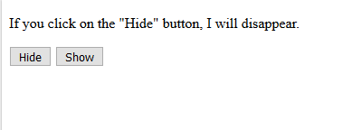

**jQuery remove() Method:**

**code:**

<!DOCTYPE html>

<html>

<head>

<script src="https://ajax.googleapis.com/ajax/libs/jquery/3.3.1/jquery.min.js"></script>

<script>

$(document).ready(function(){

$("button").click(function(){

$("#div1").remove();

});

});

</script>

</head>

<body>

<div id="div1" style="height:100px;width:300px;border:1px solid black;background-color:yellow;">

This is some text in the div.

<p>This is a paragraph in the div.</p>

<p>This is another paragraph in the div.</p>

</div>

<br>

<button>Remove div element</button>

</body>

</html>

**Output:**

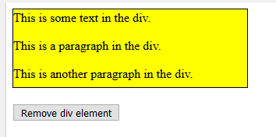

**jQuery addClass() Method:**

**code:**

<!DOCTYPE html>

<html>

<head>

<script src="https://ajax.googleapis.com/ajax/libs/jquery/3.3.1/jquery.min.js"></script>

<script>

$(document).ready(function(){

$("button").click(function(){

$("h1, h2, p").addClass("blue");

$("div").addClass("important");

});

});

</script>

<style>

.important {

font-weight: bold;

font-size: xx-large;

}

.blue {

color: blue;

}

</style>

</head>

<body>

<h1>Heading 1</h1>

<h2>Heading 2</h2>

<p>This is a paragraph.</p>

<p>This is another paragraph.</p>

<div>This is some important text!</div><br>

<button>Add classes to elements</button>

</body>

</html>

**Output:**

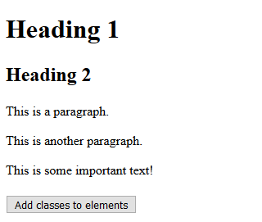

**jQuery Sliding Methods:**

**code:**

<!DOCTYPE html>

<html>

<head>

<script src="https://ajax.googleapis.com/ajax/libs/jquery/3.3.1/jquery.min.js"></script>

<script>

$(document).ready(function(){

$("#flip").click(function(){

$("#panel").slideDown("slow");

});

});

</script>

<style>

#panel, #flip {

padding: 5px;

text-align: center;

background-color: #e5eecc;

border: solid 1px #c3c3c3;

}

#panel {

padding: 50px;

display: none;

}

</style>

</head>

<body>

<div id="flip">Click to slide down panel</div>

<div id="panel">Hello world!</div>

</body>

</html>

**Output:**

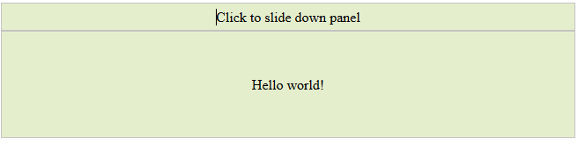

**Experiment No: 02**

**Experiment Name:** Separate the model, view, and Controller layers of an application (and implement those using Angular JS).

**AngularJS model:**

Create a model:

**Code:**

<!DOCTYPE html>

<html>

<script src="https://ajax.googleapis.com/ajax/libs/angularjs/1.6.9/angular.min.js"></script>

<body>

<div ng-app="myApp" ng-controller="myCtrl">

Name: <input ng-model="name">

</div>

<script>

var app = angular.module('myApp', []);

app.controller('myCtrl', function($scope) {

$scope.name = "John Doe";

});

</script>

<p>Use the ng-model directive to bind the value of the input field to a property made in the controller.</p>

</body>

</html>

**Output:**

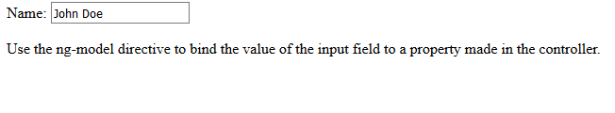**AngularJS Forms:**

**Code:**

<!DOCTYPE html>

<html lang="en">

<script src="https://ajax.googleapis.com/ajax/libs/angularjs/1.6.9/angular.min.js"></script>

<body>

<div ng-app="myApp" ng-controller="formCtrl">

<form>

First Name: <input type="text" ng-model="firstname">

</form>

</div>

<script>

var app = angular.module('myApp', []);

app.controller('formCtrl', function($scope) {

$scope.firstname = "John";

});

</script>

</body>

</html>

**Output:**



**AngularJS Filters:**

**Code:**

<!DOCTYPE html>

<html>

<script src="https://ajax.googleapis.com/ajax/libs/angularjs/1.6.9/angular.min.js"></script>

<body>

<div ng-app="myApp" ng-controller="personCtrl">

<p>The name is {{ lastName | uppercase }}</p>

</div>

<script>

angular.module('myApp', []).controller('personCtrl', function($scope) {

$scope.firstName = "John",

$scope.lastName = "Doe"

});

</script>

</body>

</html>

**Output:**

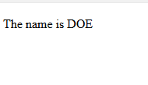

**Create single page application infrastructure:**

**Code:**

html>

<script scr="https://ajas.googleapis.com/ajax/libs/angulars/1.6.4/angular.min.js"></script>

<script scr="https://ajas.googleapis.com/ajax/libs/angulars/1.6.4/angula-route.js"></script>

<body ng-app="myApp">

<p><a href­­ =#/!">Main</a></p>

<a href="#!london">City 1</a>

<a href="#!Paris">City 1</a>

<p>Click on the links to read about London and Paris .</p>

<div ng-view></div>

<script>

var app =angular.module ("myApp",["ngRoute"]);

app.config(function($routeprovider){

$routeprovider

.when("/",{

templateUr1:"main.htm"

})

.when("/London",{

templateUr1:"London.htm"

})

.when("/paris",{

templateUr1:"paris.htm"

});

});

</script>

</body>

</html>   
**Output:**

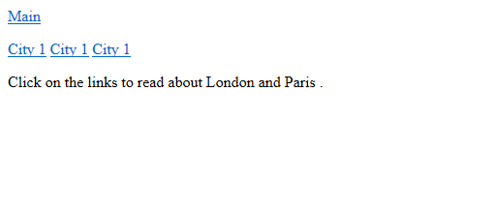

**Scope Management:**

**Code:**

<!DOCTYPE html>

<html>

<script scr="https://ajas.gooleapis.com/ajax/libs/angularjs/1.6.4/angular.min.js"></script>

<body ng-app="myApp">

<p>The rootScope's favorite color</p>

<h1>Blue</h1>

<div ng-controller ="myCtrl">

<p>The scope of the controller's favorite color :</p>

<h1>Red</h1>

</div>

<p>The rootScope's favorite color is still:</p>

<h1>Blue</h1>

<script>

var app =angular.module('myApp',[]);

app.run(function($rootScope){

$rootScope.color='blue';

});

app.ocntroller('myctrl',function ($scope){

$scope.color="red";

});

</script>

<p>Notice that controller's colro variable does not overwrite the rootScope's color

value.</P>

</body>

</html>  
**Output:**

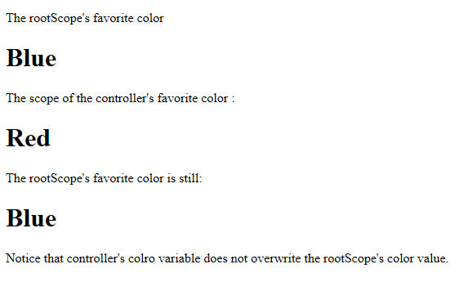

**Build a basic controller:**

**Code:**

<!DOCTYPE html>

<html>

<script src="https://ajax.googleapis.com/ajax/libs/angularjs/1.6.9/angular.min.js"></script>

<body>

<div ng-app="myApp" ng-controller="myCtrl">

First Name: <input type="text" ng-model="firstName"><br>

Last Name: <input type="text" ng-model="lastName"><br>

<br>

Full Name: {{firstName + " " + lastName}}

</div>

<script>

var app = angular.module('myApp', []);

app.controller('myCtrl', function($scope) {

$scope.firstName = "John";

$scope.lastName = "Doe";

});

</script>

</body>

</html>

**Output :**

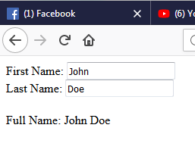

**AngularJS Expressions:**

**Code:**

<!DOCTYPE html>

<html>

<script src="https://ajax.googleapis.com/ajax/libs/angularjs/1.6.9/angular.min.js"></script>

<body>

<div ng-app>

<p>My first expression: {{ 5 + 5 }}</p>

</div>

</body>

</html>

**Output:**



**AngularJS Application:**

**Code:**

<!DOCTYPE html>

<html>

<script src="https://ajax.googleapis.com/ajax/libs/angularjs/1.6.9/angular.min.js"></script>

<body>

<script>

var app = angular.module("myShoppingList", []);

app.controller("myCtrl", function($scope) {

$scope.products = ["Milk", "Bread", "Cheese"];

});

</script>

<div ng-app="myShoppingList" ng-controller="myCtrl">

<ul>

<li ng-repeat="x in products">{{x}}</li>

</ul>

</div>

<p>So far we have made an HTML list based on the items of an array.</p>

</body>

</html>

**Output:**

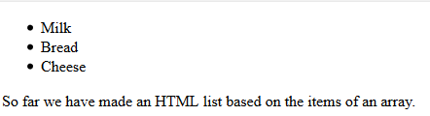

**Experiment No: 03**

**Experiment Name:** Design and development of responsive web site (Using open source Framework, Bootstrap)

**Create a bootstrap in PHP:**

**Code:**

<!DOCTYPE html>

<html lang="en">

<head>

<title>Bootstrap Example</title>

<meta charset="utf-8">

<meta name="viewport" content="width=device-width, initial-scale=1">

<link rel="stylesheet" href="https://maxcdn.bootstrapcdn.com/bootstrap/3.3.7/css/bootstrap.min.css">

<script src="https://ajax.googleapis.com/ajax/libs/jquery/3.3.1/jquery.min.js"></script>

<script src="https://maxcdn.bootstrapcdn.com/bootstrap/3.3.7/js/bootstrap.min.js"></script>

</head>

<body>

<div class="jumbotron text-center">

<h1>My First Bootstrap Page</h1>

<p>Resize this responsive page to see the effect!</p>

</div>

<div class="container">

<div class="row">

<div class="col-sm-4">

<h3>Column 1</h3>

<p>Lorem ipsum dolor sit amet, consectetur adipisicing elit...</p>

<p>Ut enim ad minim veniam, quis nostrud exercitation ullamco laboris...</p>

</div>

<div class="col-sm-4">

<h3>Column 2</h3>

<p>Lorem ipsum dolor sit amet, consectetur adipisicing elit...</p>

<p>Ut enim ad minim veniam, quis nostrud exercitation ullamco laboris...</p>

</div>

<div class="col-sm-4">

<h3>Column 3</h3>

<p>Lorem ipsum dolor sit amet, consectetur adipisicing elit...</p>

<p>Ut enim ad minim veniam, quis nostrud exercitation ullamco laboris...</p>

</div>

</div>

</div>

</body>

</html>

Output:

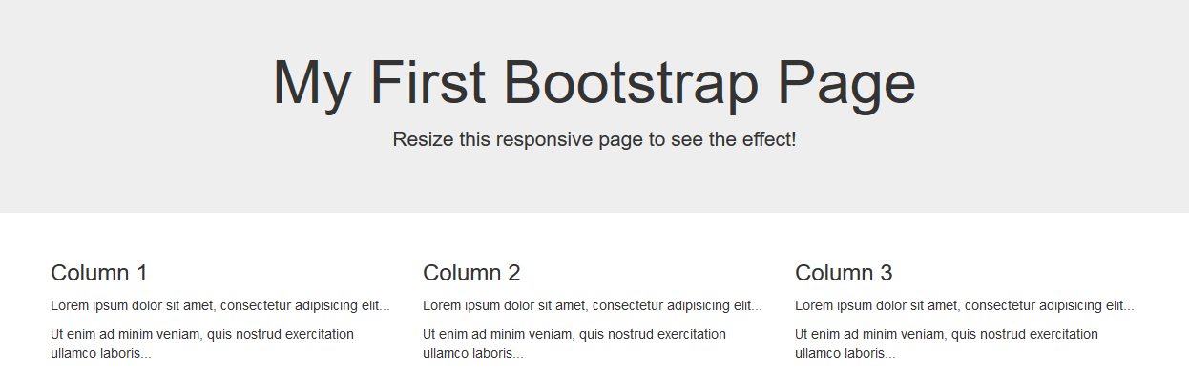

**Use a bootstrap button in PHP:**

**Code:**

<!DOCTYPE html>

<html lang="en">

<head>

<title>Bootstrap Example</title>

<meta charset="utf-8">

<meta name="viewport" content="width=device-width, initial-scale=1">

<link rel="stylesheet" href="https://maxcdn.bootstrapcdn.com/bootstrap/3.3.7/css/bootstrap.min.css">

<script src="https://ajax.googleapis.com/ajax/libs/jquery/3.3.1/jquery.min.js"></script>

<script src="https://maxcdn.bootstrapcdn.com/bootstrap/3.3.7/js/bootstrap.min.js"></script>

</head>

<body>

<div class="container">

<h2>Button Styles</h2>

<button type="button" class="btn">Basic</button>

<button type="button" class="btn btn-default">Default</button>

<button type="button" class="btn btn-primary">Primary</button>

<button type="button" class="btn btn-success">Success</button>

<button type="button" class="btn btn-info">Info</button>

<button type="button" class="btn btn-warning">Warning</button>

<button type="button" class="btn btn-danger">Danger</button>

<button type="button" class="btn btn-link">Link</button>

</div>

</body>

</html>

Output:

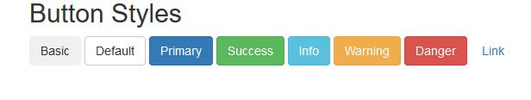

**Page components: Forms**

Create Forms:

**Code:**

<!DOCTYPE html>

<html lang="en">

<head>

<title>Bootstrap Example</title>

<meta charset="utf-8">

<meta name="viewport" content="width=device-width, initial-scale=1">

<link rel="stylesheet" href="https://maxcdn.bootstrapcdn.com/bootstrap/3.3.7/css/bootstrap.min.css">

<script src="https://ajax.googleapis.com/ajax/libs/jquery/3.3.1/jquery.min.js"></script>

<script src="https://maxcdn.bootstrapcdn.com/bootstrap/3.3.7/js/bootstrap.min.js"></script>

</head>

<body>

<div class="container">

<h2>Vertical (basic) form</h2>

<form action="/action_page.php">

<div class="form-group">

<label for="email">Email:</label>

<input type="email" class="form-control" id="email" placeholder="Enter email" name="email">

</div>

<div class="form-group">

<label for="pwd">Password:</label>

<input type="password" class="form-control" id="pwd" placeholder="Enter password" name="pwd">

</div>

<div class="checkbox">

<label><input type="checkbox" name="remember"> Remember me</label>

</div>

<button type="submit" class="btn btn-default">Submit</button>

</form>

</div>

</body>

</html>

**Output:**

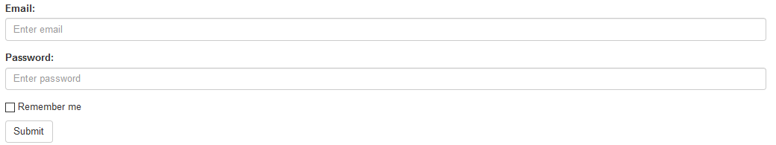

**Bootstrap Wells:**

**Code:**

<!DOCTYPE html>

<html lang="en">

<head>

<title>Bootstrap Example</title>

<meta charset="utf-8">

<meta name="viewport" content="width=device-width, initial-scale=1">

<link rel="stylesheet" href="https://maxcdn.bootstrapcdn.com/bootstrap/3.3.7/css/bootstrap.min.css">

<script src="https://ajax.googleapis.com/ajax/libs/jquery/3.3.1/jquery.min.js"></script>

<script src="https://maxcdn.bootstrapcdn.com/bootstrap/3.3.7/js/bootstrap.min.js"></script>

</head>

<body>

<div class="container">

<h2>Well</h2>

<div class="well">Basic Well</div>

</div>

</body>

</html>

**Output:**

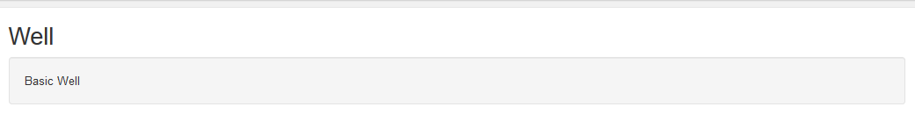

**Bootstrap plugins:**

Bootstrap JS Scrollspy:

**Code:**

<!DOCTYPE html>

<html>

<head>

<title>Bootstrap Example</title>

<meta charset="utf-8">

<meta name="viewport" content="width=device-width, initial-scale=1">

<link rel="stylesheet" href="https://maxcdn.bootstrapcdn.com/bootstrap/3.3.7/css/bootstrap.min.css">

<script src="https://ajax.googleapis.com/ajax/libs/jquery/3.3.1/jquery.min.js"></script>

<script src="https://maxcdn.bootstrapcdn.com/bootstrap/3.3.7/js/bootstrap.min.js"></script>

<style>

body {

position: relative;

}

#section1 {padding-top:50px;height:500px;color: #fff; background-color: #1E88E5;}

#section2 {padding-top:50px;height:500px;color: #fff; background-color: #673ab7;}

#section3 {padding-top:50px;height:500px;color: #fff; background-color: #ff9800;}

#section41 {padding-top:50px;height:500px;color: #fff; background-color: #00bcd4;}

#section42 {padding-top:50px;height:500px;color: #fff; background-color: #009688;}

</style>

</head>

<body data-spy="scroll" data-target=".navbar" data-offset="50">

<nav class="navbar navbar-inverse navbar-fixed-top">

<div class="container-fluid">

<div class="navbar-header">

<button type="button" class="navbar-toggle" data-toggle="collapse" data-target="#myNavbar">

<span class="icon-bar"></span>

<span class="icon-bar"></span>

<span class="icon-bar"></span>

</button>

<a class="navbar-brand" href="#">WebSiteName</a>

</div>

<div>

<div class="collapse navbar-collapse" id="myNavbar">

<ul class="nav navbar-nav">

<li><a href="#section1">Section 1</a></li>

<li><a href="#section2">Section 2</a></li>

<li><a href="#section3">Section 3</a></li>

<li class="dropdown"><a class="dropdown-toggle" data-toggle="dropdown" href="#">Section 4 <span class="caret"></span></a>

<ul class="dropdown-menu">

<li><a href="#section41">Section 4-1</a></li>

<li><a href="#section42">Section 4-2</a></li>

</ul>

</li>

</ul>

</div>

</div>

</div>

</nav>

<div id="section1" class="container-fluid">

<h1>Section 1</h1>

<p>Try to scroll this section and look at the navigation bar while scrolling! Try to scroll this section and look at the navigation bar while scrolling!</p>

<p>Try to scroll this section and look at the navigation bar while scrolling! Try to scroll this section and look at the navigation bar while scrolling!</p>

</div>

<div id="section2" class="container-fluid">

<h1>Section 2</h1>

<p>Try to scroll this section and look at the navigation bar while scrolling! Try to scroll this section and look at the navigation bar while scrolling!</p>

<p>Try to scroll this section and look at the navigation bar while scrolling! Try to scroll this section and look at the navigation bar while scrolling!</p>

</div>

<div id="section3" class="container-fluid">

<h1>Section 3</h1>

<p>Try to scroll this section and look at the navigation bar while scrolling! Try to scroll this section and look at the navigation bar while scrolling!</p>

<p>Try to scroll this section and look at the navigation bar while scrolling! Try to scroll this section and look at the navigation bar while scrolling!</p>

</div>

<div id="section41" class="container-fluid">

<h1>Section 4 Submenu 1</h1>

<p>Try to scroll this section and look at the navigation bar while scrolling! Try to scroll this section and look at the navigation bar while scrolling!</p>

<p>Try to scroll this section and look at the navigation bar while scrolling! Try to scroll this section and look at the navigation bar while scrolling!</p>

</div>

<div id="section42" class="container-fluid">

<h1>Section 4 Submenu 2</h1>

<p>Try to scroll this section and look at the navigation bar while scrolling! Try to scroll this section and look at the navigation bar while scrolling!</p>

<p>Try to scroll this section and look at the navigation bar while scrolling! Try to scroll this section and look at the navigation bar while scrolling!</p>

</div>

</body>

</html>

**Output:**

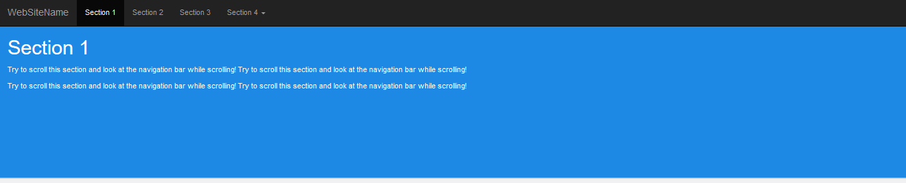

**Experiment No: 04**

**Experiment Name:** Develop website using PHP MySQL (Basic Level)

**Use code for conditional expressions:**

**Code:**

<?php

$D=Date("D");

if($D=="Sat");{

echo"have a nice day";

}

?>

**Output :**

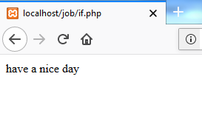

**Code:**

<?php

$t = date("H");

if ($t < "20") {

echo "Have a good day!";

} else {

echo "Have a good night!";

}

?>

**Output :**

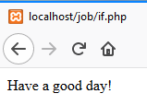

**Code:**

<?php

if ($a > $b) {

echo "a is bigger than b";

} elseif ($a == $b) {

echo "a is equal to b";

} else {

echo "a is smaller than b";

}

?>

**Output :**

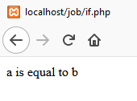

**Code:**

<?php

$favcolor = "red";

switch ($favcolor) {

case "red":

echo "Your favorite color is red!";

break;

case "blue":

echo "Your favorite color is blue!";

break;

case "green":

echo "Your favorite color is green!";

break;

default:

echo "Your favorite color is neither red, blue, nor green!";

}

?>

**Output :**

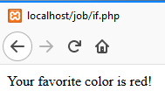

**Get data from a form:**

**Post method:**

<html>

<body>

<form action="Welcome.php" method="post">

Name:<input type="text" name="email"></br>

Email:<input type="text" name="email"></br>

<input type="Submit">

</form>

</html>

**Output:**

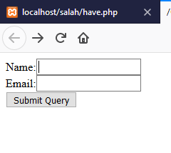

**Get data from a form show welcome.php:**

<html>

<body>

Welcome <?php echo $_POST["name"]; ?><br>

Your email address is: <?php echo $_POST["email"]; ?>

</body>

</html>

**Output:**

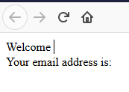

**Using $get method:**

<html>

<body>

<form action="Welcome_get.php" method="get">

Name:<input type="text" name="name"></br>

Email:<input type="text" name="email"></br>

<input type="Submit">

</form>

</body>

</html>

and "welcome_get.php" looks likes this:

<html>

welcome <?php echo $_GET["name"];?><br>

your email address is:<?php echo $_GET["email"];?>

</body>

**Output:**

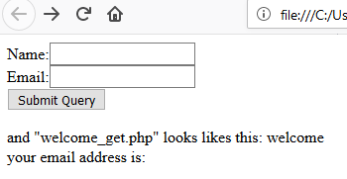

**Create Product Card Management Project:**

**Code:**

<?php

session_start();

$connect = mysqli_connect("localhost", "root", "", "test");

if(isset($_POST["add_to_cart"]))

{

if(isset($_SESSION["shopping_cart"]))

{

$item_array_id = array_column($_SESSION["shopping_cart"], "item_id");

if(!in_array($_GET["id"], $item_array_id))

{

$count = count($_SESSION["shopping_cart"]);

$item_array = array(

'item_id' => $_GET["id"],

'item_name' => $_POST["hidden_name"],

'item_price' => $_POST["hidden_price"],

'item_quantity' => $_POST["quantity"]

);

$_SESSION["shopping_cart"][$count] = $item_array;

}

else

{

echo '<script>alert("Item Already Added")</script>';

echo '<script>window.location="index.php"</script>';

}

}

else

{

$item_array = array(

'item_id' => $_GET["id"],

'item_name' => $_POST["hidden_name"],

'item_price' => $_POST["hidden_price"],

'item_quantity' => $_POST["quantity"]

);

$_SESSION["shopping_cart"][0] = $item_array;

}

}

if(isset($_GET["action"]))

{

if($_GET["action"] == "delete")

{

foreach($_SESSION["shopping_cart"] as $keys => $values)

{

if($values["item_id"] == $_GET["id"])

{

unset($_SESSION["shopping_cart"][$keys]);

echo '<script>alert("Item Removed")</script>';

echo '<script>window.location="index.php"</script>';

}

}

}

}

?>

<!DOCTYPE html>

<html>

<head>

<title>Webslesson Tutorial | Simple PHP Mysql Shopping Cart</title>

<script src="https://ajax.googleapis.com/ajax/libs/jquery/2.2.0/jquery.min.js"></script>

<link rel="stylesheet" href="https://maxcdn.bootstrapcdn.com/bootstrap/3.3.6/css/bootstrap.min.css" />

<script src="https://maxcdn.bootstrapcdn.com/bootstrap/3.3.6/js/bootstrap.min.js"></script>

</head>

<body>

<br />

<div class="container" style="width:700px;">

<h3 align="center">Simple PHP Mysql Shopping Cart</h3><br />

<?php

$query = "SELECT * FROM tbl_product ORDER BY id ASC";

$result = mysqli_query($connect, $query);

if(mysqli_num_rows($result) > 0)

{

while($row = mysqli_fetch_array($result))

{

?>

<div class="col-md-4">

<form method="post" action="index.php?action=add&id=<?php echo $row["id"]; ?>">

<div style="border:1px solid #333; background-color:#f1f1f1; border-radius:5px; padding:16px;" align="center">

<img src="<?php echo $row["image"]; ?>" class="img-responsive" /><br />

<h4 class="text-info"><?php echo $row["name"]; ?></h4>

<h4 class="text-danger">$ <?php echo $row["price"]; ?></h4>

<input type="text" name="quantity" class="form-control" value="1" />

<input type="hidden" name="hidden_name" value="<?php echo $row["name"]; ?>" />

<input type="hidden" name="hidden_price" value="<?php echo $row["price"]; ?>" />

<input type="submit" name="add_to_cart" style="margin-top:5px;" class="btn btn-success" value="Add to Cart" />

</div>

</form>

</div>

<?php

}

}

?>

<div style="clear:both"></div>

<br />

<h3>Order Details</h3>

<div class="table-responsive">

<table class="table table-bordered">

<tr>

<th width="40%">Item Name</th>

<th width="10%">Quantity</th>

<th width="20%">Price</th>

<th width="15%">Total</th>

<th width="5%">Action</th>

</tr>

<?php

if(!empty($_SESSION["shopping_cart"]))

{

$total = 0;

foreach($_SESSION["shopping_cart"] as $keys => $values)

{

?>

<tr>

<td><?php echo $values["item_name"]; ?></td>

<td><?php echo $values["item_quantity"]; ?></td>

<td>$ <?php echo $values["item_price"]; ?></td>

<td>$ <?php echo number_format($values["item_quantity"] * $values["item_price"], 2); ?></td>

<td><a href="index.php?action=delete&id=<?php echo $values["item_id"]; ?>"><span class="text-danger">Remove</span></a></td>

</tr>

<?php

$total = $total + ($values["item_quantity"] * $values["item_price"]);

}

?>

<tr>

<td colspan="3" align="right">Total</td>

<td align="right">$ <?php echo number_format($total, 2); ?></td>

<td></td>

</tr>

<?php

}

?>

</table>

</div>

</div>

<br />

</body>

</html>

To keep product data, create a test database in mysql, after which it creates a table called tbl_product.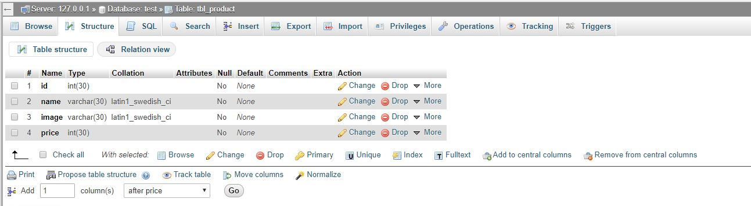

Enter the necessary products with the name of the picture.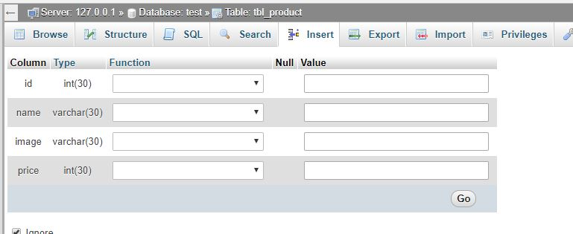

**Output:**

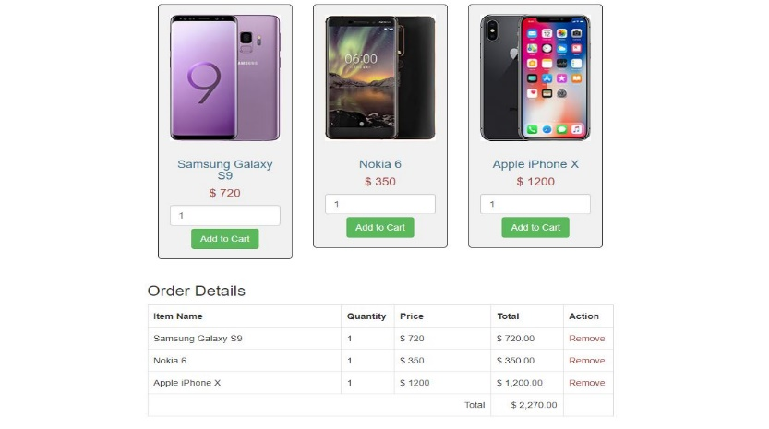

**if statement used a php program:**

**Code:**

If Statement:

<?php

$x = 9;

$y = 'webcoach';

if (is_int($x) && is_string($y)){// check if $x integer & if $y string

echo 'Yes bouth expression are returned true';

}

?>

**Output:**

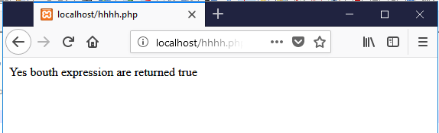

If…..else Statement:

<?php

$d=date ("D");

if ($d=="Sat"){

echo "Have a nice day";

}else{

echo "Today is not saturday";

}

?>

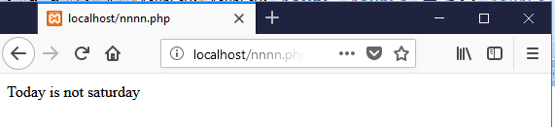

**If…elseif…else** **Statement:**

**Code:**

<?php

$number = 50; //provide any number

if ($number == 60){

echo "The number is 60";

}elseif ($number == 45){

echo "The number is 45";

}elseif ($number == 33){

echo "The number is 33";

}else{

echo "No number";

}

?>

**Output:**

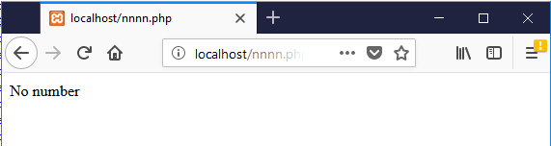

**Create and use arrays:**

**Code:**

<!DOCTYPE html>  
<html>  
<body>  
<?php  
$cars = array("Volvo", "BMW", "Toyota");   
echo "I like " . $cars[0] . ", " . $cars[1] . " and " . $cars[2] . ".";  
?>  
</body>  
</html>

**Output:**

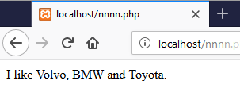

**Test and debug a PHP Application:**

**Code:**

<?php

hello world!

?>

**After Debug code:**

<?php

echo "hello world!"

?>

**Output :**

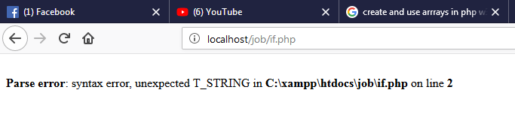

**After Debug Output :**

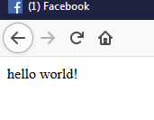

**Using PHP while loop:**

**code for while loop:**

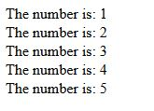<!DOCTYPE html>  
<html>  
<body>  
  
<?php    
$x = 1;  
   
while($x <= 5) {  
  echo "The number is: $x <br>";  
  $x++;  
}   
?>    
  
</body>  
</html>

**Output:**

**Using for loop in PHP:**

**code: for loop.**

<!DOCTYPE html>  
<html>  
<body>  
  
<?php    
for ($x = 0; $x <= 10; $x++) {  
  echo "The number is: $x <br>";  
}  
?>    
  
</body>  
</html>

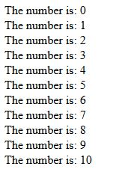**Output:**

**Find date and time in PHP:**

**code:**

<!DOCTYPE html>  
<html>  
<body>  
<?php  
echo "Today is " . date("Y/m/d") . "<br>";  
echo "Today is " . date("Y.m.d") . "<br>";  
echo "Today is " . date("Y-m-d") . "<br>";  
echo "Today is " . date("l");  
?>  
</body>  
</html>

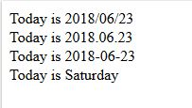**Output:**

**Include and requires in PHP:**

**code:**

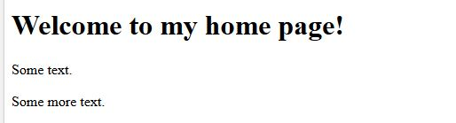<!DOCTYPE html>  
<html>  
<body>  
<h1>Welcome to my home page!</h1>  
<p>Some text.</p>  
<p>Some more text.</p>  
<?php include 'footer.php';?>  
</body>  
</html>

**Output:**

**Switch statement in PHP:**

**code:**

<!DOCTYPE html>  
<html>  
<body>  
<?php  
$favcolor = "red";  
switch ($favcolor) {  
    case "red":  
        echo "Your favorite color is red!";  
        break;  
    case "blue":  
        echo "Your favorite color is blue!";  
        break;  
    case "green":  
        echo "Your favorite color is green!";  
        break;  
    default:  
        echo "Your favorite color is neither red, blue, nor green!";  
}  
?>  
   
</body>  
</html>

**dm.JPGOutput:**

**PHP form url/email:**

**code:**  
<?php  
// define variables and set to empty values  
$nameErr = $emailErr = $genderErr = $websiteErr = "";  
$name = $email = $gender = $comment = $website = "";  
  
if ($_SERVER["REQUEST_METHOD"] == "POST") {  
  if (empty($_POST["name"])) {  
    $nameErr = "Name is required";  
  } else {  
    $name = test_input($_POST["name"]);  
    // check if name only contains letters and whitespace  
    if (!preg_match("/^[a-zA-Z ]*$/",$name)) {  
      $nameErr = "Only letters and white space allowed";   
    }  
  }  
    
  if (empty($_POST["email"])) {  
    $emailErr = "Email is required";  
  } else {  
    $email = test_input($_POST["email"]);  
    // check if e-mail address is well-formed  
    if (!filter_var($email, FILTER_VALIDATE_EMAIL)) {  
      $emailErr = "Invalid email format";   
    }  
  }  
      
  if (empty($_POST["website"])) {  
    $website = "";  
  } else {  
    $website = test_input($_POST["website"]);  
    // check if URL address syntax is valid  
    if (!preg_match("/\b(?:(?:https?|ftp):\/\/|www\.)[-a-z0-9+&@#\/%?=~_|!:,.;]*[-a-z0-9+&@#\/%=~_|]/i",$website)) {  
      $websiteErr = "Invalid URL";   
    }      
  }  
  
  if (empty($_POST["comment"])) {  
    $comment = "";  
  } else {  
    $comment = test_input($_POST["comment"]);  
  }  
  
  if (empty($_POST["gender"])) {  
    $genderErr = "Gender is required";  
  } else {  
    $gender = test_input($_POST["gender"]);  
  }  
}  
  
function test_input($data) {  
  $data = trim($data);  
  $data = stripslashes($data);  
  $data = htmlspecialchars($data);  
  return $data;  
}  
?>  
  
<h2>PHP Form Validation Example</h2>  
<p><span class="error">* required field</span></p>  
<form method="post" action="<?php echo htmlspecialchars($_SERVER["PHP_SELF"]);?>">    
  Name: <input type="text" name="name">  
  <span class="error">* <?php echo $nameErr;?></span>  
  <br><br>  
  E-mail: <input type="text" name="email">  
  <span class="error">* <?php echo $emailErr;?></span>  
  <br><br>  
  Website: <input type="text" name="website">  
  <span class="error"><?php echo $websiteErr;?></span>  
  <br><br>  
  Comment: <textarea name="comment" rows="5" cols="40"></textarea>  
  <br><br>  
  Gender:  
  <input type="radio" name="gender" value="female">Female  
  <input type="radio" name="gender" value="male">Male  
  <input type="radio" name="gender" value="other">Other  
  <span class="error">* <?php echo $genderErr;?></span>  
  <br><br>  
  <input type="submit" name="submit" value="Submit">    
</form>  
  
<?php  
echo "<h2>Your Input:</h2>";  
echo $name;  
echo "<br>";  
echo $email;  
echo "<br>";  
echo $website;  
echo "<br>";  
echo $comment;  
echo "<br>";  
echo $gender;  
?>  
  
</body>  
</html>

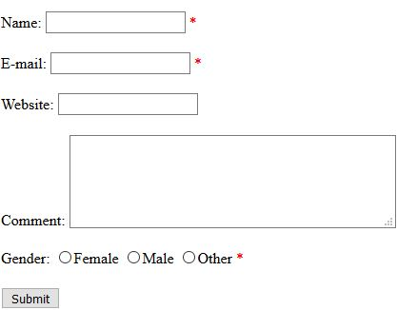**Output:**

**PHP arrays multi:**

**code:**

<!DOCTYPE html>  
<html>  
<body>  
<?php  
$cars = array  
  (  
  array("Volvo",22,18),  
  array("BMW",15,13),  
  array("Saab",5,2),  
  array("Land Rover",17,15)  
  );  
  echo $cars[0][0].": In stock: ".$cars[0][1].", sold: ".$cars[0][2].".<br>";  
echo $cars[1][0].": In stock: ".$cars[1][1].", sold: ".$cars[1][2].".<br>";  
echo $cars[2][0].": In stock: ".$cars[2][1].", sold: ".$cars[2][2].".<br>";  
echo $cars[3][0].": In stock: ".$cars[3][1].", sold: ".$cars[3][2].".<br>";  
?>  
</body>  
</html>

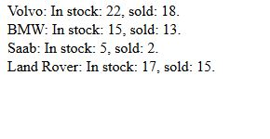**Output:**